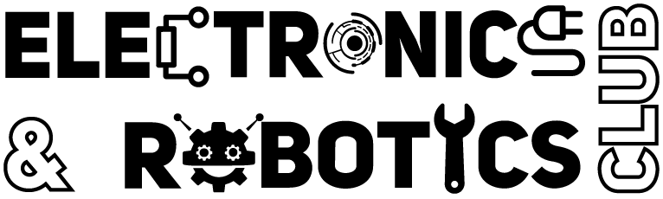
ERC FRESHMAN ORIENTATION
Hands-On-Activity
Mini Tesla ⚡– ‘Power Through Air’
Idea –
- The activity demonstrates wireless power transfer using Electromagnetic Induction.
- Students build a simple system where electrical energy is transmitted through air from one coil (transmitter) to another (receiver), lighting an LED without any physical connection.
- The goal is to give students an intuitive understanding of how modern technologies like wireless charging work through a fun, hands-on experiment.
Working Principle –
According to Faraday’s and Lenz Law of Electromagnetic Induction (students must have studied during JEE), if a closed coil/loop placed near to some other circuit with varying magnetic field, then some amount of current also goes into the coil, a phenomenon also known as mutual induction.
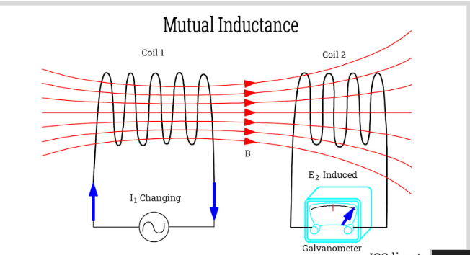
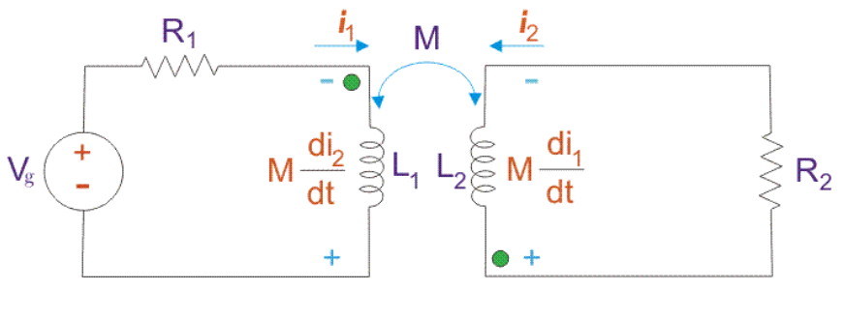If the current is alternating (AC) or changing in coil1, the magnetic field strength and direction changes and magnetic flux due to the coil1 vary. So, when coil2 brought near to coil1, this changing flux creates a tangential electric field, pushing electrons through coil2 to move, showing the galvanometer deflection.

Components & Bill of Materials (BOM) –
Component | Quantity | Approx Cost (Rs) (from robu.in)
BC547 Transistor | 1 | 5-10
470Ω Resistor | 1 | 1-2
1kΩ Resistor | 1 | 1-2
Red LED | 1 | 2-5
Copper Wire (28-32 AWG, ~1-2m) | 1 | 15-20
10nF Capacitor | 1 | 1-2
9V HW Battery | 1 | 30-35
Jumper Wires (Male-Male) | 1 set (10 wires) | 10-20
Small Breadboard | 2 | 30-35

So, Approx total cost ~160 rupees
Thus, cost of 300 kits will be around 48k rupees

- Transistor BC547 (Assume flat face towards you)
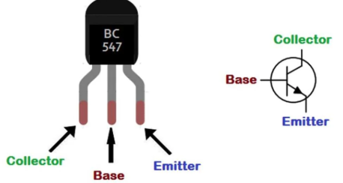
The BC547 is an NPN (Negative-Positive-Negative) bipolar junction transistor, which acts as an electronic switch that is turned on and off by electricity instead of our finger. It has three pins, and each plays a very specific role:
- Pin 1: The Collector (The “Heavy Inlet”) It handles the high-power load. When the transistor turns on, the Collector allows the power that has built up in the coil to rush into the transistor.
- Pin 2: The Base (The "Control Valve") It acts like a gatekeeper. When a tiny amount of positive current is pushed into the Base, it opens the "gate" between the Collector and the Emitter. In this oscillator circuit, the Base receives high-frequency pulses from the capacitor, causing it to rapidly snap the on/off switch from Collector to Emitter.
- Pin 3: The Emitter (The “Exhaust/Drain”) It connects directly to the negative side of the battery (ground). Both the small control current from the Base and the large power current from the Collector merge together and exit through the Emitter to complete the circuit.

- Copper Coils (Can be prepared by rounding wire on circular bottles or pipes)
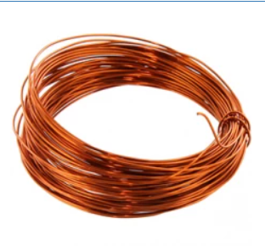
It serves a dual purpose. First, it resists sudden changes in current, which helps generate the high-voltage spikes needed to keep the capacitor and transistor oscillating. Second, as the transistor forcefully pulses current through it thousands of times a second, the coil acts as an antenna, broadcasting that pulsing energy out into the air as a high-frequency magnetic field. And the receiver coil gets the energy and lights up the LED.

- Battery HW 9V (with connector cap)
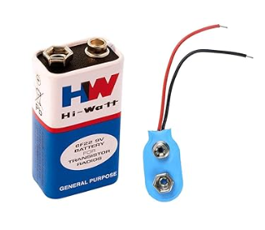
It provides the raw, flat, direct current (DC) energy. The entire job of the rest of the circuit is simply to take this flat energy and convert it up into waves so it can be transmitted wirelessly.
- Resistor 1K ohm
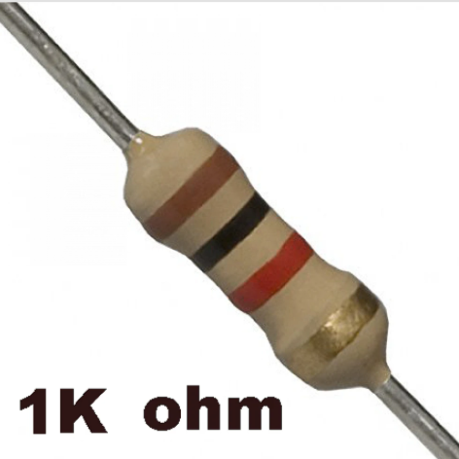
It has two uses. Firstly, it drops the battery voltage down to a safe value, so it doesn't instantly burn out the sensitive Base pin of the transistor. Second, it provides the initial "bias"—a constant, small nudge of power to wake the transistor up and get the first cycle of the oscillation started when you connect the battery.
- Red LED (for better Visibility)
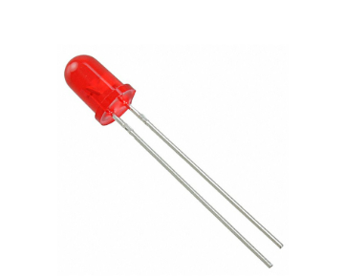
Lights up when Coil2 receives the pulsating energy coming from the transmitter Coil1.
- Breadboard
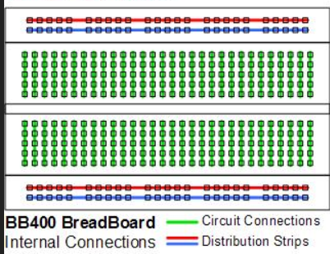
Provides better space for connections, to not mess up the wiring.

- Capacitor 10nF
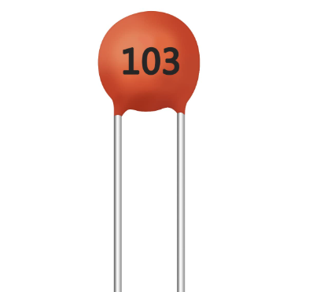
It creates the feedback loop. When the coil's magnetic field collapses, it creates a sudden spike of voltage. The capacitor catches this spike at the Collector, blocks the standard battery DC, and passes only the high-voltage spike back to the Base. This kicks the transistor back on, creating a continuous, self-sustaining loop (oscillation).

- Resistor 470ohm
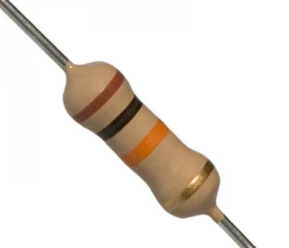
It prevents the LED from burnout if sudden high current flows in the receiver circuit.

Circuit Connections:
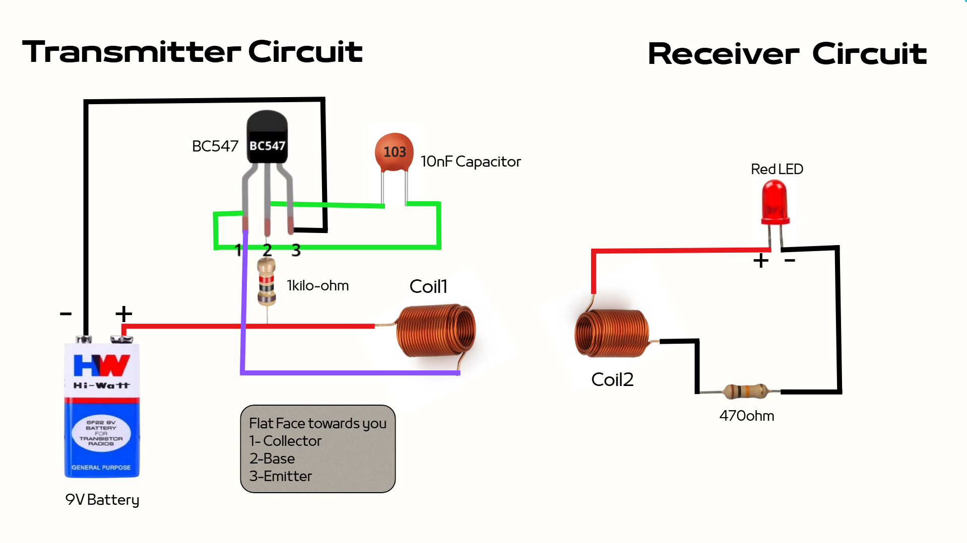
Explanation for the connections: -
- Battery Positive (+) to the Coil: Supplies the main, raw power that the coil will eventually broadcast as a magnetic field.
- Battery Positive (+) to the Resistor: Draw off a tiny fraction of the main battery power to act as a starter signal.
- Resistor to the Base (Pin 2): Delivers that tiny starter signal safely into the transistor's control pin to wake it up without damaging pins.
- Coil to the Collector (Pin 1): Connects the heavy power load to the transistor's main inlet. When the transistor turns on, it pulls current through this connection.
- Collector (Pin 1) to the Capacitor: Placed right at the main power inlet to catch the energy spike that bounces back when the coil turns off.
- Capacitor to the Base (Pin 2): Takes that captured energy spike and feeds it right back into the control pin. This forces the transistor to snap back on again, creating the endless, high-speed on/off loop (oscillation).
- Emitter (Pin 3) to Battery Negative (-): Acts as the main ground connection. All the current from the Base and the Collector merges here and flows back to the battery, completing the entire circuit.

Booyah! Mini Tesla ⚡ Works

------------------------------------------------------THE END--------------------------------------------------------

